Homework for week 2, submission deadline 23:59 on Sunday night.
- Choose your own topics from following list or your own.
- Gut microbiota and metabolic disease
- Single-cell transcriptomics in cancer immunology
- Antibiotic resistance genomics
- Epigenetic regulation in neurological disorders
- Muscle regeneration and aging
- Proteomic biomarkers in MAFLD/MASH
Finish the following question section we covered in the class
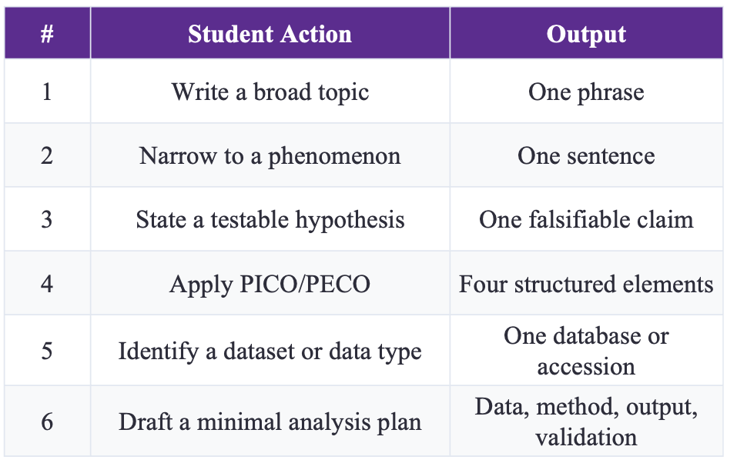
- Find and read two research papers in the folder and answer following question based on these two papers.
  - Question 1: Use the PICO/PECO, what are they for these two papers?
  - Question 2: What kind of dataset or data type these two papers use?
  - Question 3: What is the hypothesis of these two research?

- Based on your research interest, refine the search in PUBMED, and sort, identify the latest and the most important studies in your field. Read this paper and answer three questions:
  - Question 1: Use the PICO/PECO, what are they for these two papers?
  - Question 2: What kind of dataset or data type these two papers use?
  - Question 3: What is the hypothesis of these two research?

